**After the 1st Stop** & Start:

**USE-PRD-OMPAPP2**

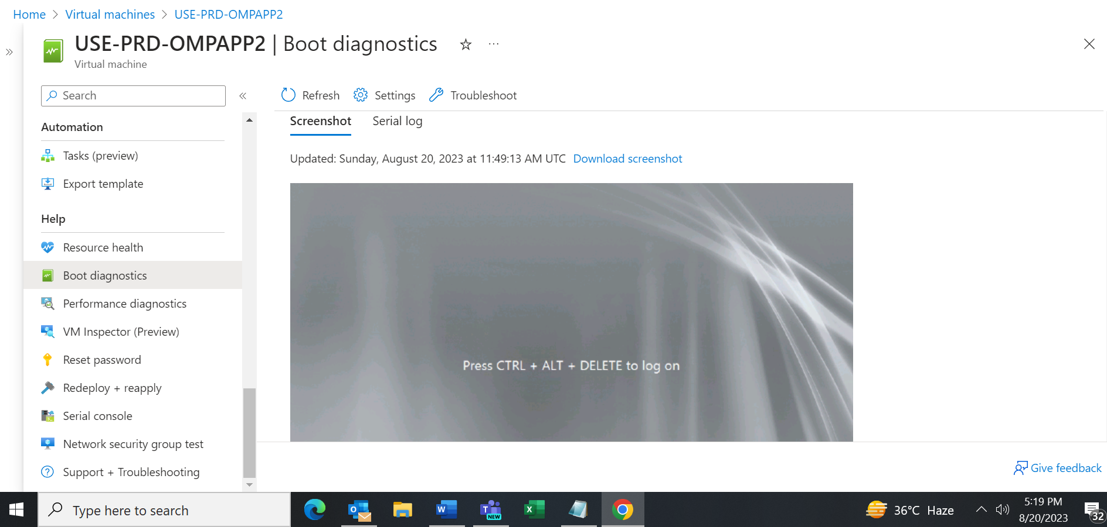

**USE-PRD-OMPAPP3**

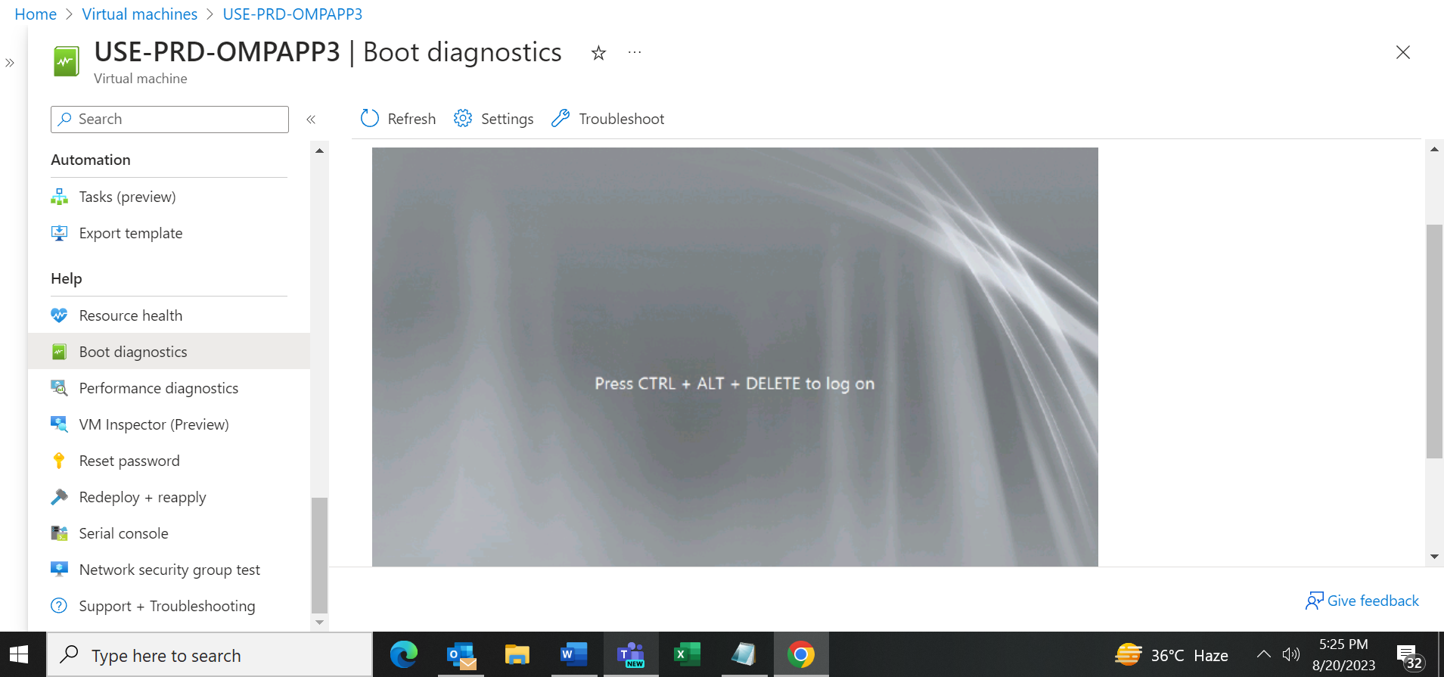

**USE-PRD-OMPAPP4**

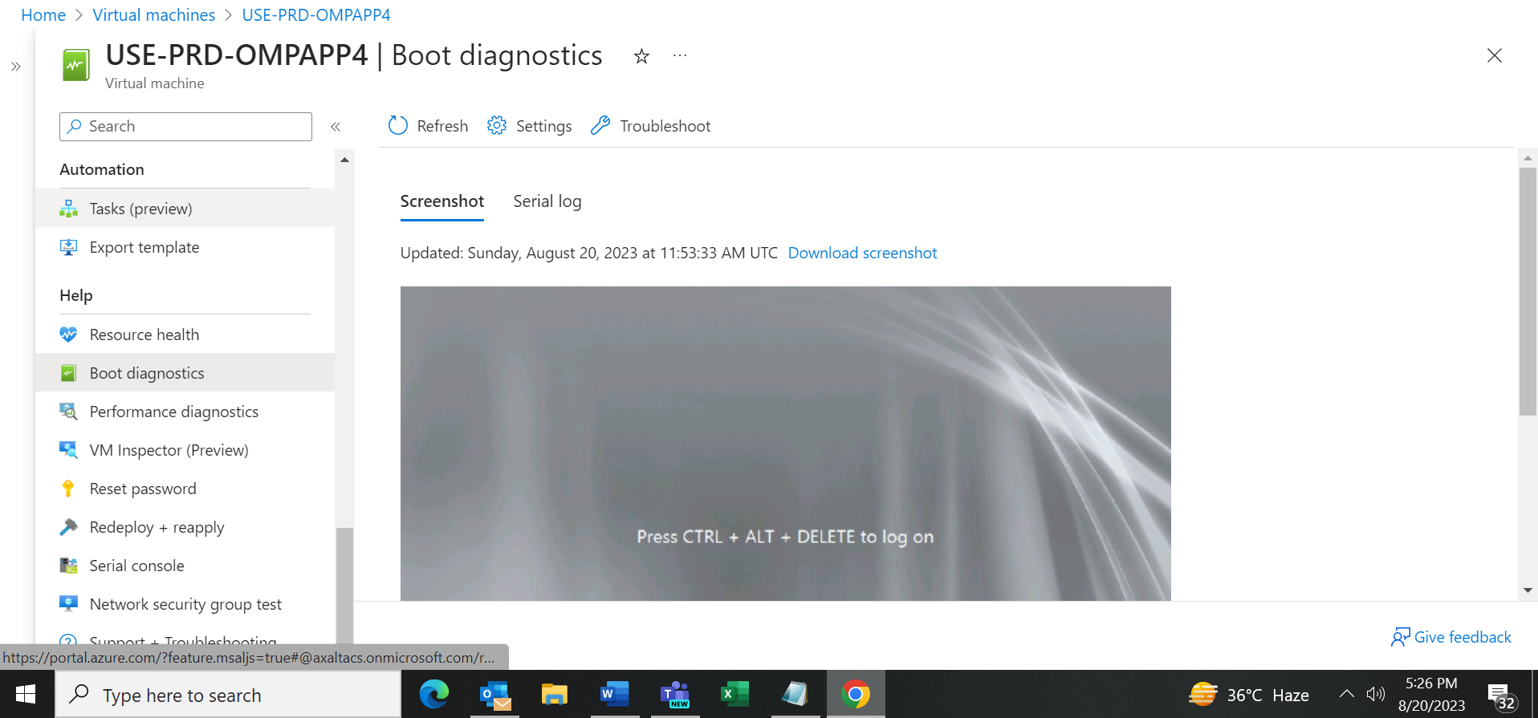

**USE-PRD-OMPAPP5**

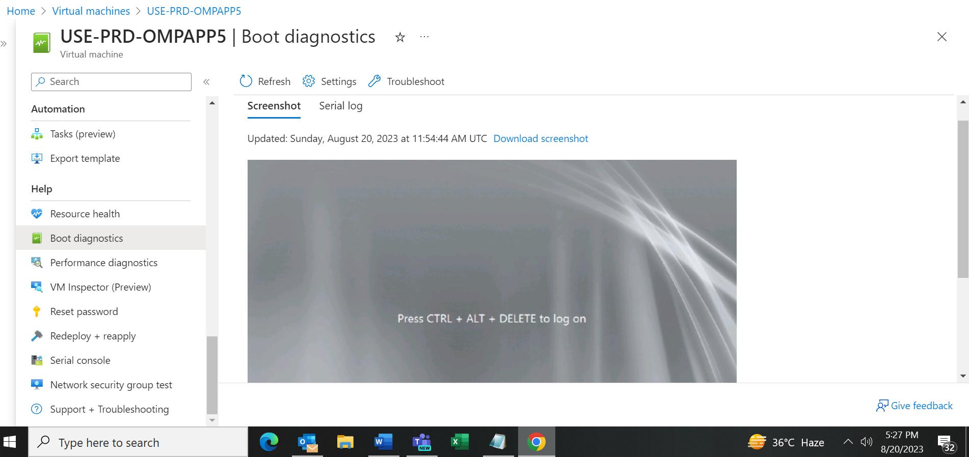

**USE-PRD-OMPAPP6**

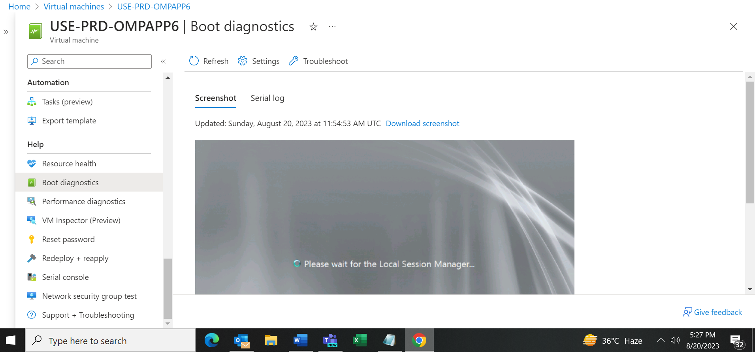

**USE-PRD-OMPAPP7**

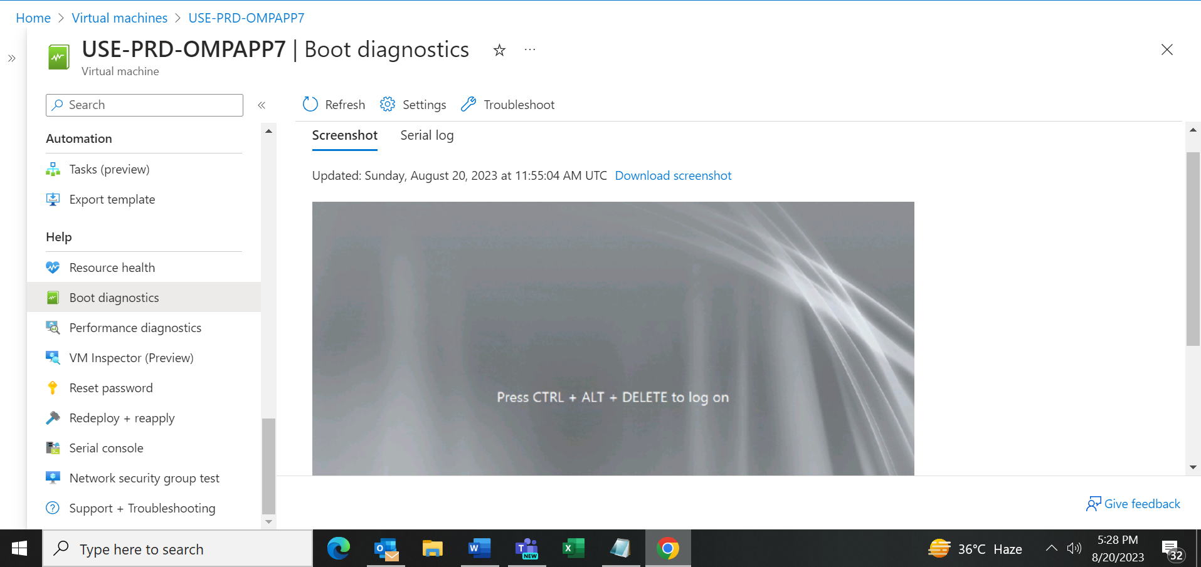

**USE-PRD-OMPAPP9**

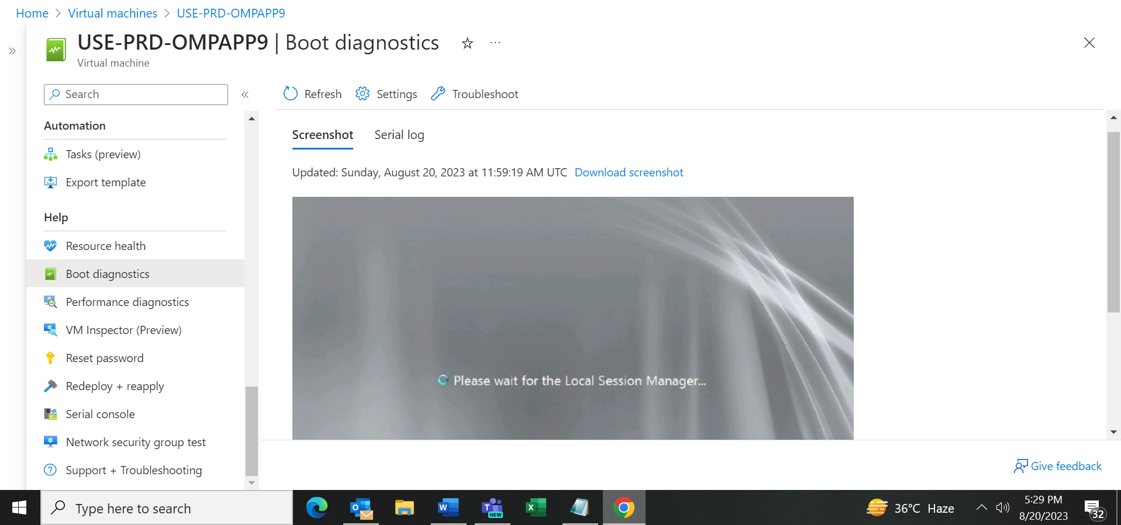

**USE-PRD-OMPAPPE**

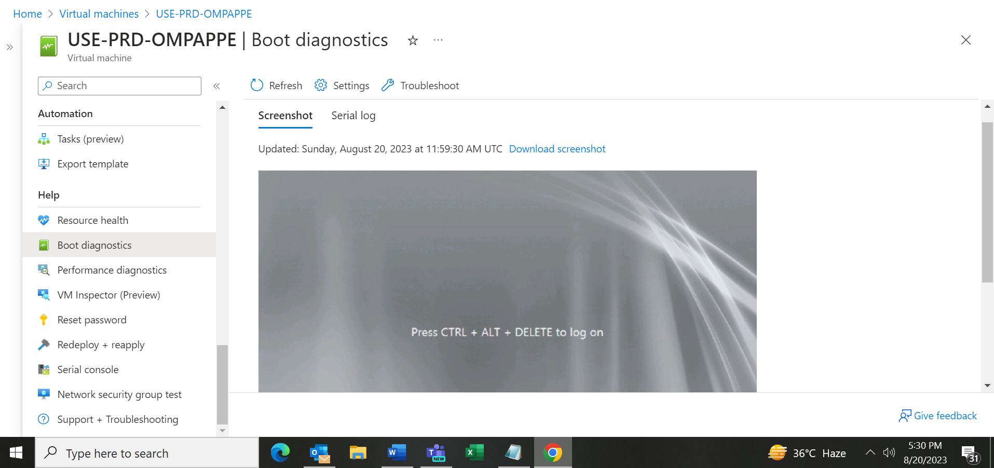

**USE-PRD-OMPAPPG**

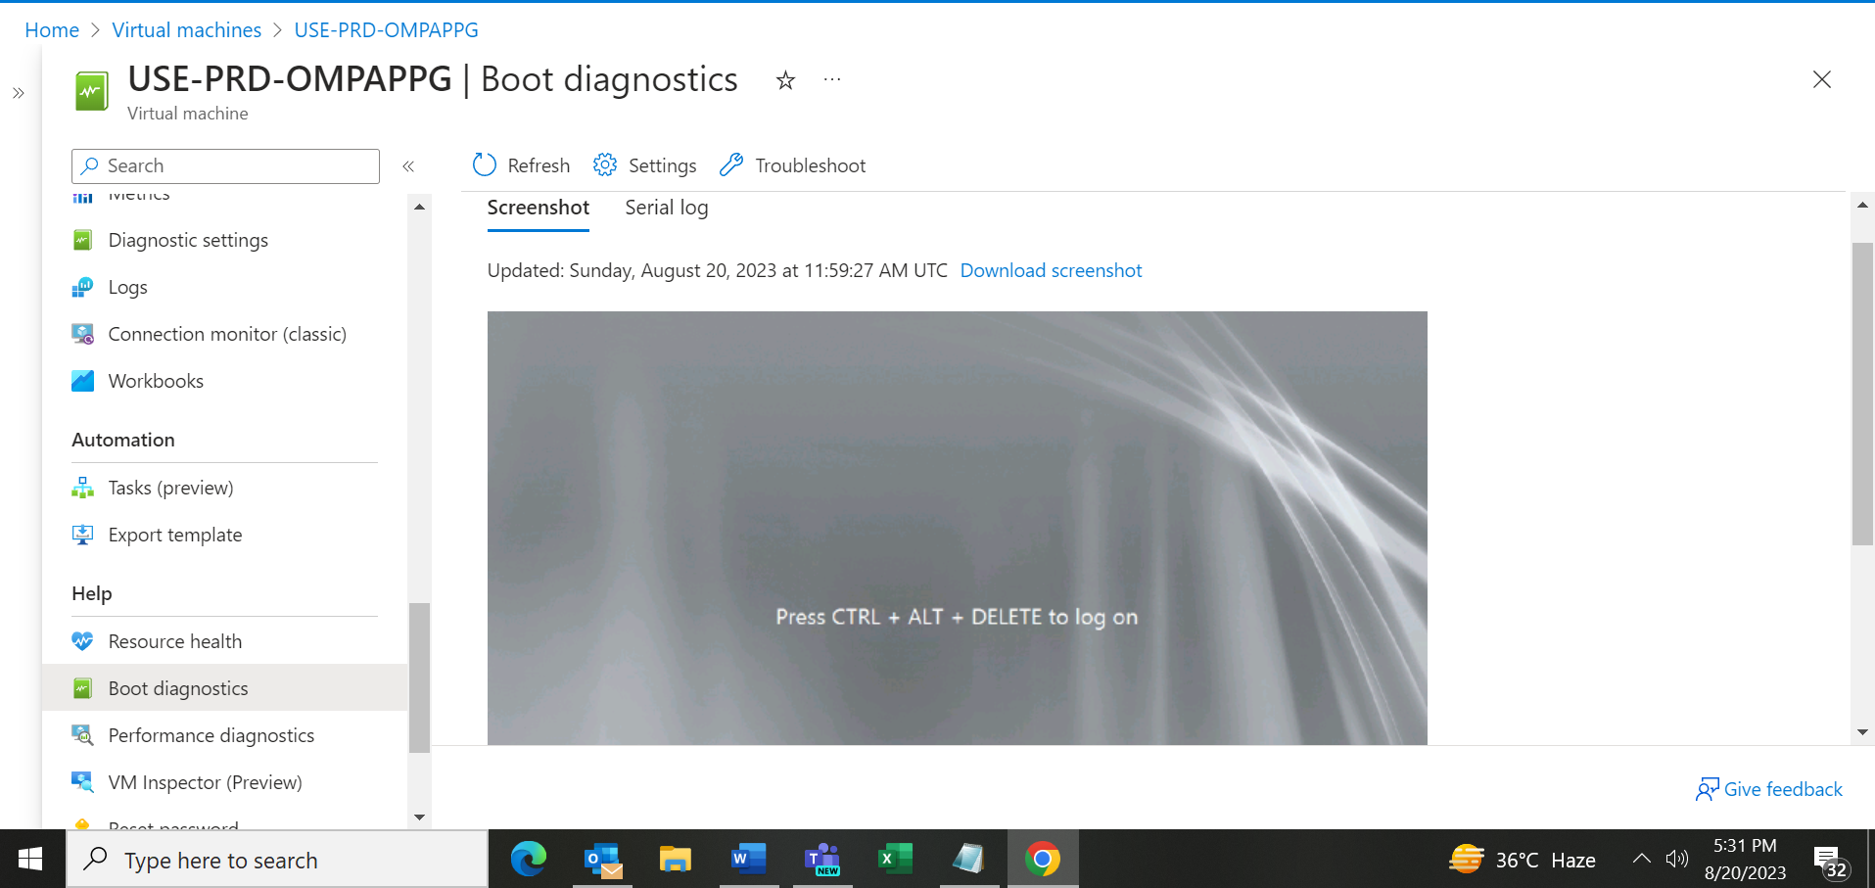

**After 2nd Start & Stop**

**USE-PRD-OMPAPP2 (**Machine is still starting in the last 18 Minutes**)**

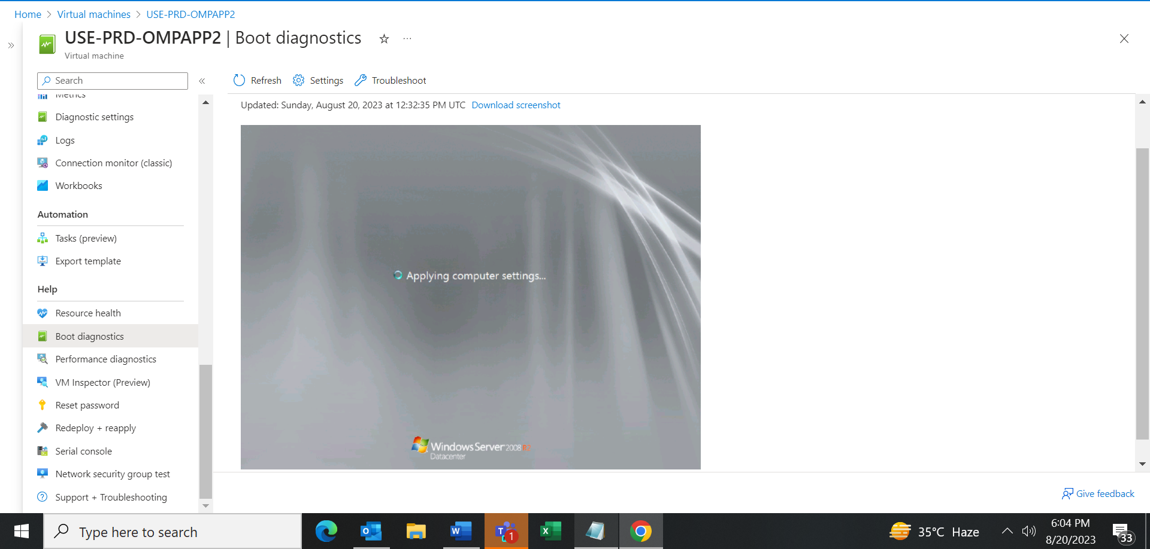

USE-PRD-OMPAPP7

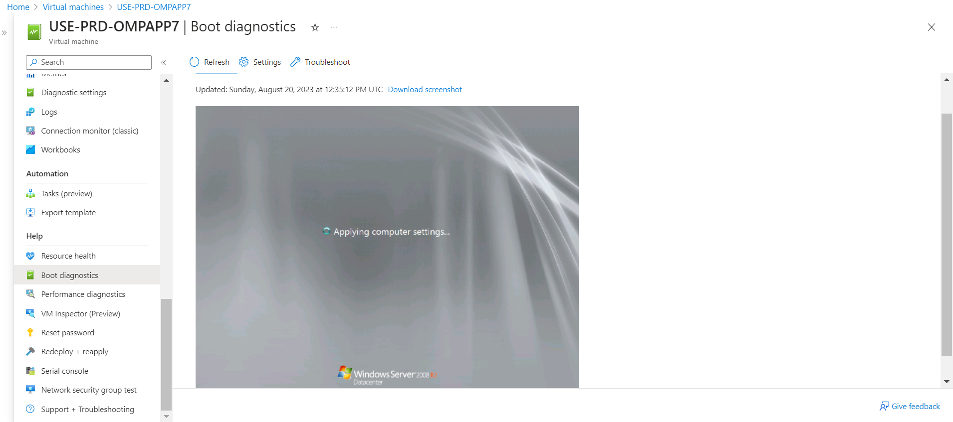

USE-PRD-OMPAPP4

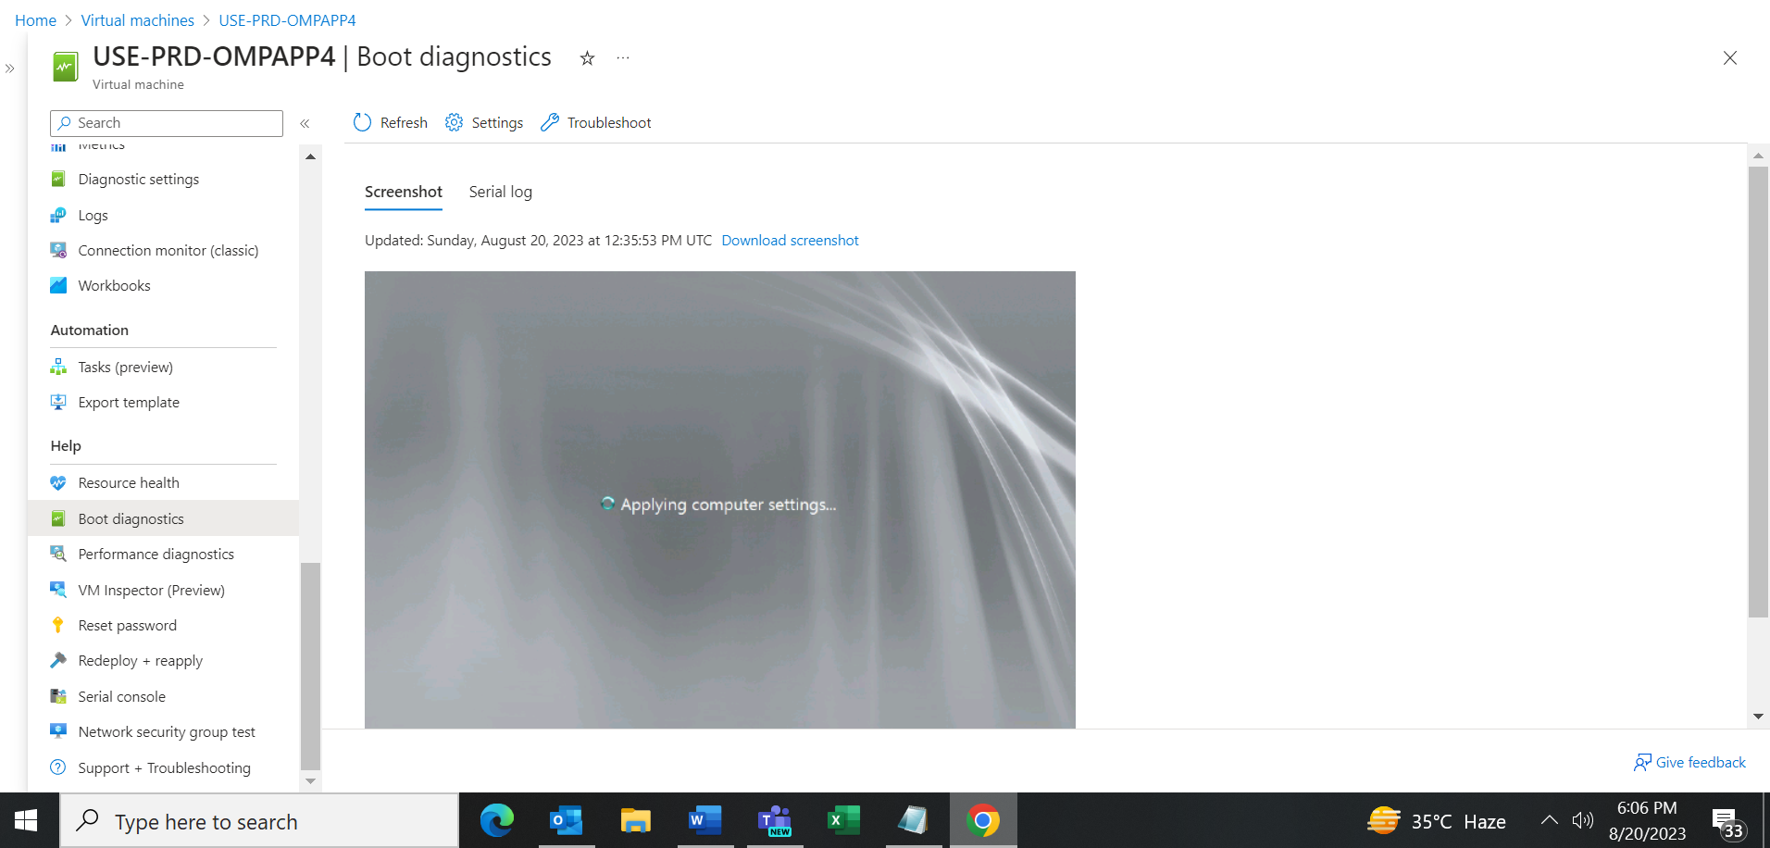

**3rd Start and Stop**

USE-PRD-OMPAPP7 (Still starting since last 24 Minutes)

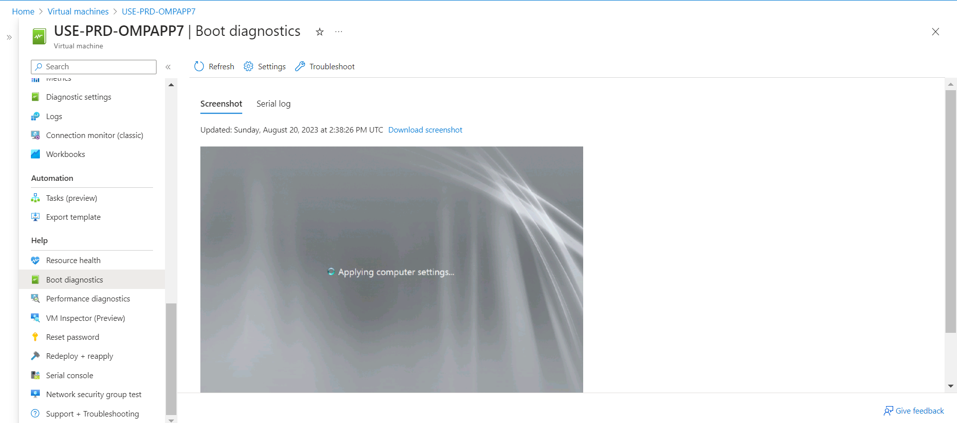

USE-PRD-OMPAPP4 (Still starting since last 24 Minutes)

